CHAPTER 1

INTRODUCTION

* 1. DESCRIPTION:

While there is a great deal of information available about the travel characteristics of individuals traveling for all kinds of purposes on a day to day basis, little is known about the travel characteristics of emergency vehicles. To this end, an underlying aim of this research is to assist the transportation and emergency vehicle communities in acquiring a better understanding of emergency vehicle operations, travel patterns and associated characteristics. The characteristics that merit special attention include temporal and spatial distribution of emergency vehicle travel; frequency of emergency vehicle responses by time of day; the extent to which such responses include two or more emergency vehicles; and the impacts of emergency vehicle travel on the transportation System.

Understanding the characteristics of emergency vehicles is an important and fundamental element in designing and deploying an emergency signal preemption system. Over the last few years, a great deal of attention has been provided for the safe and efficient movement of emergency vehicles. Communities are turning to emergency vehicle preemption systems at traffic signals in order to improve emergency vehicle response time and safety, as well as to resolve the challenges that gridlock situations present to drivers of emergency vehicles. To this context, transportation planners and engineers need knowledge and tools to assist in identifying emergency vehicle preemption candidate intersections based on traffic operations and safety objectives.

Emergency Vehicle Preemption (EVP) is a form of preferential treatment given to emergency vehicles to minimize the waiting required at signalized intersections. Traditional preemption works on the principle that the emergency vehicle is detected by a controller as it approaches an intersection and is given an earlier green or extended green, depending on the phase of the controller, until the emergency vehicle exits that intersection.

Most preemption systems in the United States operate on an intersection-by-intersection basis. An emergency vehicle is detected by sensors at each controller and each individual intersection is preempted in order, resulting in the preemption of each intersection only after the emergency vehicle reaches it. This may result in the emergency vehicle stopping after each intersection as it waits for vehicles to clear. This also causes confusion for drivers in other vehicles about whether to pull over or proceed in the presence of an emergency vehicle at a preempted green.

Limited research is done in developing a route clearance strategies for the emergency vehicles.Thus,it remains a wide area of interest to the study.

Providing safe and fast driving environment for emergency vehicles, so that they can reach their destinations at the earliest possible time, is of critical importance in saving lives and reducing property loss.

While substantial progress has been made in the areas of vehicle detection and communication technologies, current state-of-the-art in signal preemption in the U.S. has not reached the point where route-based signal clearance strategies can be automatically generated and implemented in real time. To be sure, most preemption systems developed to date operate on a single-intersection basis and require local detection of an emergency vehicle to activate a signal preemption sequence at each intersection.

* 1. MOTIVATION

There exist several problems with the Ambulance and trucks on their emergency.

This study utilizes the hardware already existing in most smartphones to transmit GPS signals to a server, which in turn computes and sends signal commands to the traffic signal via Internet or LAN. The existing microcontroller in the traffic signals just needs to be modified with an Ethernet Shield to connect to the web server. Thus costs are reduced and Traffic Signal Preemption System can be implemented easily.

1.3. BACKGROUND

Emergency vehicles, such as, fire trucks, ambulances and police vehicles should be able to respond to emergency calls for an incident with a minimum delay. The level of emergency service is determined by how rapidly the responder arrives at the incident location. Although signalized vehicle preemption is a relatively recent development resulting from advancements in Intelligent Transportation Systems (ITS), the concept of prioritizing emergency vehicle movement is not. The American Engineering Council indicated in its 1929 publication Street Traffic Signs, Signals and Markings that “In any coordinated system, supplemental arrangements may be provided for breaking the system into smaller units for emergency operation, such as the runs of fire apparatus”. Emergency vehicles were and are still prioritized on streets using sirens and strobe lights. But intersections remained to hinder it from moving uninterruptedly. In the 1960s, hardware technology to detect vehicles using vehicle-based emitters and signal-based detectors emerged.

Advancements in ITS have changed the technology used in emergency vehicle preemption. Automatic Vehicle Location (AVL) systems using Global Positioning Systems (GPS) and Vehicle to Roadside Communication (VRC) systems using encrypted infrared and radio waves are hardware advancements in the preemption industry. However, little change has been made to preemption logic. Currently, the majority of systems in the United States are structured as detection, preemption and transition systems, which involve detection of emergency vehicles which invoke preemption of an intersection and controller switches to a predefined preemptive phase. In 2007, the Research and Innovative Technology Administration (RITA) surveyed major metropolitan areas about ITS deployment including emergency vehicle preemption systems. These surveys indicated the use of some type of EVP system in almost 93 metropolitan areas. Over 33,000 intersections, or 24% of the total number of signalized intersections, are found to have some sort of EVP mechanism in place. Survey results also show that nearly 4,800 emergency vehicles are equipped with Vehicle-to-Roadside Communication (VRC) devices and 4,650 emergency vehicles use Automatic Vehicle Location (AVL) Systems.

The major preemption technologies currently used are light and infrared based systems, sound-based systems and radio-based systems. Each of these systems has its own advantages and disadvantages as shown in Table 1.

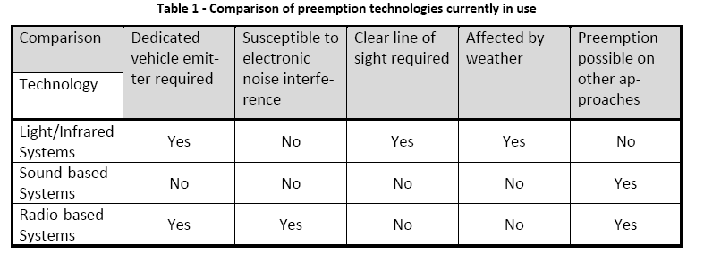

The goal of preemption at both coordinated and non-coordinated signalized intersections is to reduce travel time of emergency vehicles. However, current vehicle preemption techniques do not perform well along congested corridors where spillbacks and gridlock can occur. In such conditions, even when the emergency vehicle preempts a signal controller, the queued vehicles from the next intersection delays movement because the emergency vehicle cannot preempt that controller until it is within range of the VRC. In such situations, the preemption needs advanced clearing of downstream approaches so that the emergency vehicle can move with minimal delay or stops. Without such a preemption technique, the traditional intersection-by-intersection preemption results in longer travel times for both the emergency vehicle and other traffic, degrading the corridor and intersection levels of service.

Research has shown that methods of preemption which are route-wide can reduce emergency response times. Technology for communicating between the controller and emergency vehicles are now available and can aid implementation of systems which involve real-time congestion monitoring. Also, more corridors are being monitored for traffic conditions using vehicle detection and traffic flow measurement systems. These improvements, along with increasing congestion, have provided the tools and motivation for the development of a traffic adaptive offset-based preemption method for emergency vehicles.

The system requires emergency vehicles to be equipped with a transmitter that can be activated on demand via a control frequency that employs an encrypted data stream. When an emergency vehicle begins approaching an intersection, the transmitter is activated and a signal is relayed to a receiver located on the light assembly. The transmitted signal can be detected from a distance of up to 2,000 feet. Until the signal is detected, the sign remains unlit with a dark face. When the transmitter is activated, the sign displays an image of a Ambulance/fire-truck providing a visual warning to motorists regarding the oncoming emergency vehicle. The display flashes once per second, until the emergency vehicle has cleared the intersection. The receiver monitors signal strength and the device automatically shuts off after a preset time interval when a drop in signal strength has occurred. A schematic diagram illustrating the operation of the system is shown in Figure 1.1.

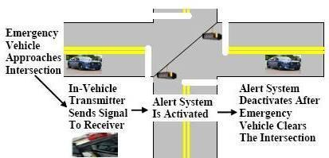

FIGURE1.1: Operation of emergency vehicle preemption

1.4. RESEARCH OBJECTIVE

The goal of this research is to develop and evaluate a preemption method for emergency vehicles which utilizes the available technology and minimize the travel-time of emergency vehicles and thereby improve emergency level of service. Objectives of this research are to:

1. Develop a preemption method which utilizes information from real-time traffic monitoring to provide a faster emergency response without compromising safety.

2. Evaluate the method using a case study for its effectiveness in providing faster emergency response and minimizing its impact on overall traffic.

1.5. RESEARCH TASK

The following tasks were involved in the development of the offset-based preemption method for emergency vehicles.

* A comprehensive review of the available literature was performed covering the research done in the field of emergency vehicle preemption.
* The guidelines for EVP in the Manual on Uniform Traffic Control Devices (MUTCD) were reviewed so that safe transition to preemption can be considered in this research.
* Traffic flow characteristics pertaining to movement of vehicles at a signalized intersection and queue accumulation were studied.
* Equations were developed for the dynamic offset-based preemption using real-time traffic variables.
* A working model was built for a case study using available data to execute the pro-posed method.

1.6. FEASIBILITY STUDY

The feasibility of the project is analyzed in this phase and business proposal is put forth with a very general plan for the project and some cost estimates. During system analysis the feasibility study of the proposed system is to be carried out. This is to ensure that the proposed system is not a burden to the company. For feasibility analysis, some understanding of the major requirements for the system is essential.

Three key considerations involved in the feasibility analysis are

* Economic Feasibility
* Technical Feasibility
* Social Feasibility

1.6.1. ECONOMIC FEASIBILTY

This study is carried out to check the economic impact that the system will have on the organization. The amount of fund that the company can pour into the research and development of the system is limited. The expenditures must be justified. Thus the developed system as well within the budget and this was achieved because most of the technologies used are freely available. Only the customized products had to be purchased.

### 1.6.2 . TECHNICAL FEASIBILTY

This study is carried out to check the technical feasibility, that is, the technical requirements of the system. Any system developed must not have a high demand on the available technical resources. This will lead to high demands on the available technical resources. This will lead to high demands being placed on the client. The developed system must have a modest requirement, as only minimal changes are required for implementing this system.

1.6.3. SOCIAL FEASIBILTY

The aspect of study is to check the level of acceptance of the system by the user. This includes the process of training the user to use the system efficiently. The user must not feel threatened by the system, instead must accept it as a necessity. The level of acceptance by the users solely depends on the methods that are employed to educate the user about the system and to make him familiar with it. His level of confidence must be raised so that he is also able to make some constructive criticism, which is welcomed, as he is the final user of the system.